Mr. David Pearce

Greetings. I am about to give you a gift. Properly executed, this idea/proposal, will make you the first inner world astronaut, a user of the first “paradise engineering” device. By the pressing of a sub-dermal membrane switch you will send a small amount of electricity into the nucleus accumbens, thus inducing a cascade of waves of pleasure. By means of this writing, I hereby make the design of the Nirvana device, described below, freely available to anyone who would like to build one by declaring it Open Source, (but this does not apply to the Face-Lifter® itself, which is patented).

“The Nirvana: Intra-scalp Deep Brain Stimulation (DBS) Face-Lifter®”: Using an intra-scalp Face-Lifter® as a stand or support for a brain pacemaker to electrically stimulate the brain’s nucleus accumbens (pleasure center) in order to:
-Attaining a pleasurable state of being at the pressing of a sub-dermal switch,
-Helping treat depression,
-Combating drug addiction.

At the core of the DBS is an implanted pulse generator (IPG) a battery-powered neurostimulator, mounted or embedded on an intra-scalp medical-grade solid silicon Face-Lifter®. As soon as the user has the desire to go into a rapture of pleasure, (or he/she feels the on-rise of the depression symptoms, or the need to have access to the drug to which he is addicted to), he would simply press an implanted sub-dermal switch, thus sending out a small electric current to his nucleus accumbens (pleasure center of the brain), which upon being so stimulated, would instantly produce a pleasurable sensation, just for the enjoyment of the hedonistic pleasure itself, (or, in case it is used therapeutically, for eliminating or palliating the depression’s effects and/or eliminating the need to ingest the addicting drug). The IPG can be calibrated by a neurologist, nurse or trained technician to optimize symptom suppression and control side effects.

Basic Parts:
-A solid silicon intra-scalp Face-Lifter® array
-Rechargeable battery
-Extension cord, its terminal end wearing a micro-electrode array
-Electricity-production dilemma solved by the use of electricity-producing head motion-device (similar to Seiko’s® “Kinetic”® watch). No need for periodical battery replacement
-Sub-dermal silicone strap, 10” long x ½” wide, containing wiring and a flat, membrane-type, micro-switch at its end.
Embedded into the medical grade silicone matrix of the intra-scalp Face-Lifter® array comes a) a rechargeable battery, b) an electricity-producing motion-device (similar to Seiko´s® “Kinetic”® watches), c) a thin sub-dermal silicone side strap carrying wiring and sub-dermal switch on one of the sides of the face-lifter, and d) a silicon-encased, micro-electrode array tipped-extension cord.

The sub-dermal silicone strap, 10” long x ½” wide, implanted also under the skin, contains wiring with a flat, membrane-type switch at its tip. Additionally, a remote control is supplied.
ADVANTAGES:
- Minimally-invasive process.
- Minimum down-time: user may leave the hospital the same day of the procedure.
- Minimum amount of trauma or scarring.
- The placement itself is performed without discomfort and under local anesthesia (endoscopy).
- The intra-scalp Face-Lifter® device cannot be noticed from the outside.
- Affordable procedure and hardware, cost-wise.
- The improvement uses currently-existing and everyday used technologies.
- Power-production dilemma solved by the use of electricity-producing head and eye motion-device (similar to Seiko’s® “Kinetic”® watch). No need of surgery for periodical battery replacement.
The Face-Lifter® is, technically, a very safe implant that goes on top of the head, right under the scalp’s skin (remember the American Indians trophy collection: human scalps?: They detach that easily!).
PROCEDURE:

Three incisions total have to be made on the scalp: one 4 inch long incision on the back of the head for placing the Face-Lifter® under the scalp, and two additional one-inch incisions (one to insert the electrode-tipped, silicon-encased extension cord that goes into the nucleus accumbens, another for implanting the sub-dermal on-off flat membrane-type switch).

In order to apply the local anesthesia, the surgeon injects all areas of the patient’s scalp with Xylocaine. He then makes a 4 in long incision on the scalp skin in the parietal area (no need to shave hair, as long as it is a perpendicular incision). Infiltrate under the scalp to be raised using a tumescent solution. Elevate the skin off of the skull bone by pushing in the silicone Face-Lifter array (embedded battery, power-producing device, switch-carrying side strap, extension cord) or first detaching the scalp from the skull bone with the help of a round-tip silicone spatula.

Insert the Face-Lifter® array, half way in.

Next, the surgeon makes a small incision on top of the head, near the bregma, folding back a small flap of skin to expose the bone. Using a high speed hand drill, the surgeon makes two small holes on top of the skull bone. One hole is for inserting the extension cord (electrode at its tip) that leads to the nucleus accumbens; the second hole is for inserting a flexible endoscope provided with a slipping loop at its end (or a grasping device).

The endoscope’s loop is used to fasten the extension cord wire just lying beneath the first hole. The extension cord is then pulled down. Manipulating the endoscope, the surgeon then guides the extension cord, down- and frontward, following the curvature of the frontal bone, and then down again until reaching the floor of the cranial space, then through the longitudinal fissure, until it reaches the midbrain, at the top of the brainstem, where the nucleus accumbens is located. The extension cord carries an electrode array sheath of platinum-iridium micro-electrodes at its terminal end. The surgeon then tightly fastens the electrode array to the nucleus accumbens. The implanted pulse generator is now in place.
To put the sub-dermal membrane switch in place, a one, half-inch incision, is made in the Temporal Area of either side of the head, and vertically detaching a thin strip of skin from the temporal area until reaching the cheekbone, by means of pushing in a thin, round-edge silicon spatula through the locally anesthetized skin. Slid the flat, membrane-type, On-Off switch, sub-dermally.
Finish the procedure by pushing in the Face-Lifter® assembly to its final position under the scalp. The surgeon finally closes the three small openings of the scalp with sutures and/or staples.

You are now ready to enjoy Nirvana, by simply pressing the button in your cheek!!!

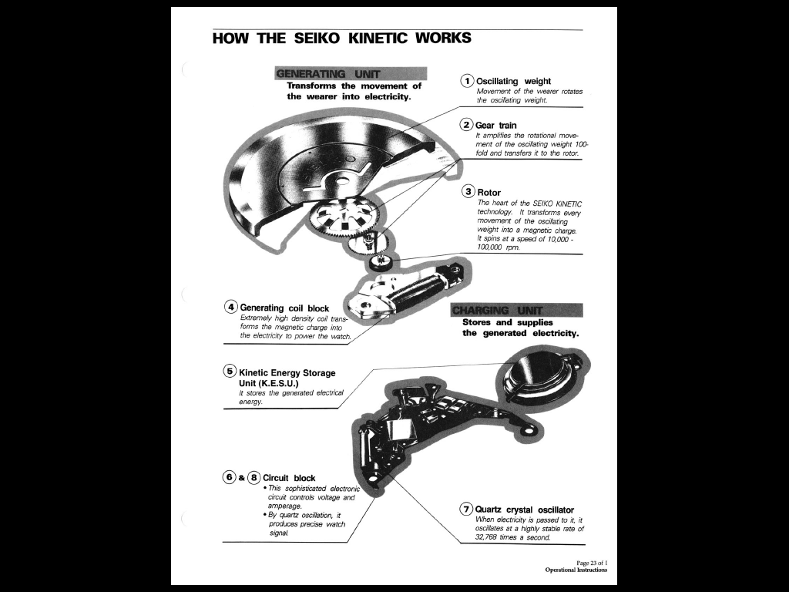

Battery Pack

Head
Motion
Electricity-
Producing
Device
Intra-scalp
Silicone
Face-Lifter

Electrode-tipped
Silicon-covered
Extension cord
Into nucleus accumbens

On-Off
Sub-dermal
Switch

About the Face-Lifter®.

The Instant Face-Lifter® is an intra-scalp beautifying device that helps stretch the face´s skin thus instantly improving the face by creating a brighter, softer, fresher appearance with minimum scarring. It consists of an oval-shaped device made of flexible, solid, hypo-allergenic medical grade silicone (or other biocompatible material), typically measuring 5 12/16“ long x 4 12/16” wide, with sloping edges and an ever increasing thickness in the direction from border to center, starting at a negligible thickness at the borders and increasing to a varying maximum thickness (i.e. ½”, ¾”, 1”, or 1 ½”) at its center as to be able to provide the user the desired amount of skin stretching effect. The upper part of the invention follows a curve which parallels the shape of the head so the device remains unnoticed from the outside. The invention is slided in the space between the skin of the scalp and the galea aponeurotica of the user through a 4” incision on the parietal (back of the head) area using local anesthesia. The implant can be put in place in the convenience of one´s home, or at the Doctor`s Office; the placement itself is performed without discomfort and under local anesthesia.

ELEVATION VIEW
Scale: 1 inch

PLAN VIEW

Other inventions that may be of help to blind people (synopsis):
“Restoring Eyesight to the Blind by Partially-Invasive, Optical Nerve-Video Camera Interaction: Coupling Imaging from a Video Camera (Implanted inside Eyeball) with a Chip-fitted Face-Lifter®.” Achieving Sustitute Vision by direct Optical Nerve stimulation or by direct lateral geniculate nucleus stimulation or by direct primary visual cortex (V1) stimulation. Using implanted video camera imaging-chip interaction for replicating and thus restoring the vision process. Key words: Cybersenses, Artificial vision, Vision substitution, Synthetic vision technologies.

Another idea to help quadriplegic people (synopsis):
“Non-Invasive, Bluetooth-mediated, Brain-Computer Interface (BCI) by means of an Electrode Array/Amplifier-fitted Intra-scalp Face-Lifter®” Using an electrode-array-and-amplifier-fitted intra-scalp Face-Lifter® for relaying the amplified brain signals picked up above the skull bone through an intra-scalp Bluetooth sending device to an external PC as non-invasive brain-computer interface for people with moving disabilities.
Intended audience: 1) Airplane pilots free-handedly flying servo-controlled aircraft. 2) Vehicle drivers manning free-handedly servo-controlled cars. 3) Handicapped people: robotic arm PC-driven.

Another design: electrodes resting directly on the cortex, for quadriplegic people (synopsis)::
“Partially Invasive, Bluetooth-mediated, Direct Brain Interface to be used with Assistive Technologies for Quadriplegic People by means of an Amplifier-fitted Intra-scalp Face-Lifter®”: Using an amplifier-fitted intra-scalp Face-Lifter® for sending the amplified brain signals picked up by an array of implanted electrodes, resting directly on the cortex, to an external PC via an intra-scalp Bluetooth device as partially invasive, direct brain interface, to be used with assistive technologies for quadriplegic people.

And another, to help deaf people (synopsis):
“Restoring Hearing to the Deaf by Partially-Invasive, Bluetooth-and-Chip-Mediated, Auditory Nerve-External Microphone Interaction by means of a Face-Lifter® Assembly:” Achieving Artificial Hearing by Direct Auditory Nerve stimulation requiring the conversion of microphone-generated sound signals to electric impulses for nerve stimulation produced by a Bluetooth and sound signal processing chip-fitted intra-scalp Face-Lifter®. Key words: Artificial hearing, Hearing substitution, Ear bypass, Synthetic hearing technologies, Cybersenses, Face-Lifter.

All these applications came up from reading your articles on wireheading. Once again, I would like to make these designs freely available to anyone who would like to build one by declaring them Open Source, (NOTE: but this does not apply to the Face-Lifter® itself, which is patented).

First, some background. I have been a college Biochemistry professor for the last 20 years and part-time inventor. I am in the process of patenting a beautifying device, which I call the Face-Lifter®, meant for the 80MM Americans (Baby-Boomers) aged between 45-60. Since I filed for the US Application I have been receiving a plethora of ideas of different applications for the Face-Lifter. After reading your most interesting articles on wireheading, the ideas just presented and others have came up.

So, thanks for your inspirations and ideals.
One unsolicited advice: have an electronic engineer put a built-in timer in the array…so you may have only some X hours a day of hedonistic enjoyment or bliss, but with a self-imposed limit of your own choosing… This is to allow you to have a “normal” life, without breaking the 1,500 presses/hour winning mark!!! (please do watch the movie “Brainstorm, a 1983 science fiction film directed by Douglas Trumbull and starring Christopher Walken and Natalie Wood,: in one scene, the co-inventor of “the Hat” device got hooked for hours, replaying orgasms endlessly…so, beware of this, please).
Be at peace. Be happy. Be free. Best regards, Ricardo.

